# Johans Wallet

HpHWSSdpAZDA6PS8dAB8cuhdFyXFjRSQcmHC78X3WF65

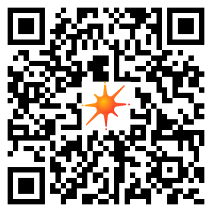

# Ankis Wallet

DpMsov6it3QgTyzHp87r6YpRLobuhb4cUKHzGy4977hF

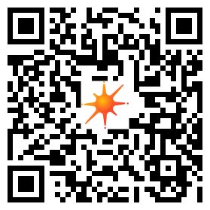

# Lottas Wallet

2FnVmxy2ZcfSN8sW8CM3bcbuV1SCzjEPjR9LMK1rAXLX

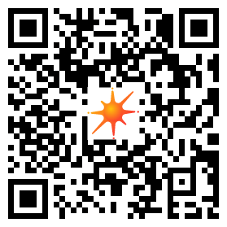

# Tinas Wallet

86K7mWz8WukzbEFr1itiJQoAeeeCvQDArW4L8eTEfimg

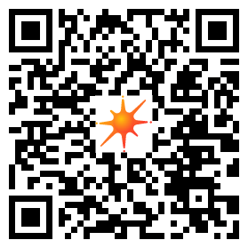

# Manges Wallet

5rMcedDmZRxFekLDyaSnri6149HGJZ1EEJpnJr2MwuZN



# Wendpaap Bank

9TpjWpX7Sn7hCVo8eqNfQnCpKgeWTqiafVYHMdzSoSMV

# Wallet Aps

## Crome extention:

<https://phantom.app/>

## On mobile

Kiwi browser <https://play.google.com/store/apps/details?id=com.kiwibrowser.browser&hl=sv&gl=US>  
Använd Phantom app (se ovan)

Alternativ: Solflare

Android: <https://play.google.com/store/apps/details?id=com.solflare.mobile>

Apple: <https://apps.apple.com/us/app/solflare/id1580902717>